1 Hour and 30 minutes

THE UNIVERSITY OF MANCHESTER

EART26201 Principles of Geochemistry

?? January 2025

Time: ??:?? - ??:??

Answer ALL questions in the booklets provided.
Clearly label which question each of your answers corresponds to. All writing must be LEGIBLE. Illegible documents cannot be marked.
There are 100 marks available on this paper. The number of marks for each question is shown and may be used as a guide to how much time you should spend on each.
You may wish to use labelled sketches to illustrate your answers where appropriate.
The use of calculators is permitted, as long as they cannot store text, perform algebra and have no graphing capability.

© The University of Manchester, 2025

Question 1

- With reference to the Gibbs phase rule (𝒇=𝒄−𝚽+𝟐), describe the variance at the features labelled 1, 2 and 3 on the SiO₂ phase diagram below, noting the nature of components and phases at each feature. [10 marks]
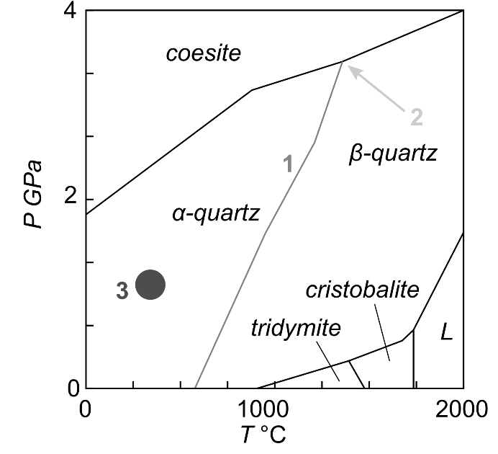

- Univariant line where 1 component (SiO₂) and 2 phases (α-quartz and β-quartz) result in 1 degree of freedom; P and T cannot change independently without changing the system, but coupled changes in P and T are possible
- Invariant point where 1 component (SiO₂) and 3 phases (α-quartz, β-quartz and coesite) result in 0 degrees of freedom; neither P nor T can change without changing the system
- Divarient field where 1 component (SiO₂) and 1 phase (α-quartz) result in 2 degrees of freedom; P and T can change independently without changing the system

- With reference to the phase diagram below, describe and contrast equilibrium and fractional crystallisation of a liquid with the bulk composition X_{An}=0.6 [20 marks]
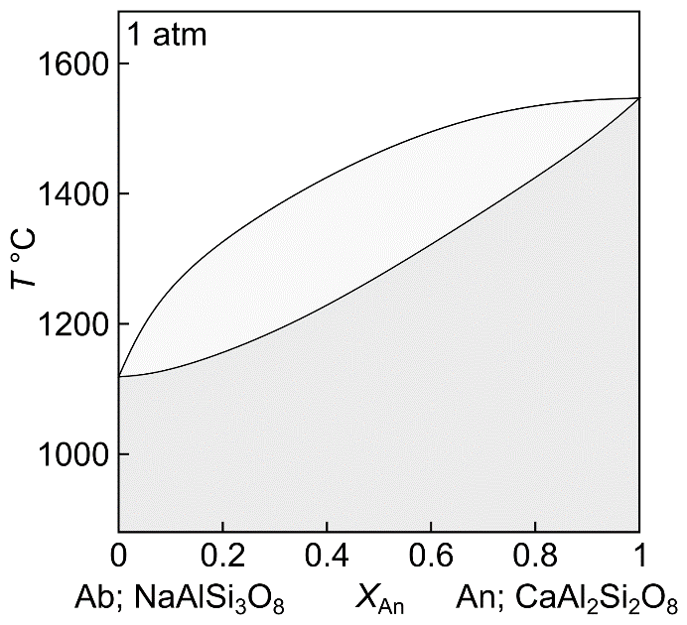

During equilibrium crystallisation, the first plagioclase crystals form when the system composition intersects the liquidus at ~1500°C and have a composition of XAn~0.9. As the system cools, both the liquid and plagioclase evolve to lower XAn contents. At ~1330°C the final liquid solidifies to XAn=0.6 plagioclase. Liquid and plagioclase remain in equilibrium throughout. Phase rule can be used to estimate phase proportions for top marks.

During fractional crystallisation, the first plagioclase crystals also form at ~1500°C and have a composition of XAn~0.9. However, these plagioclase crystals leave the system as soon as they are formed, such that the liquid composition evolved all the way down the liquidus to XAn=0 at ~1120°C, where the final liquid crystallises to form XAn=0 crystals.

Two key differences between equilibrium and fractional crystallisation are that the system fully solidifies at a higher temperature (1330°C) during equilibrium crystallisation that fractional crystallisation (~1120°C), and that equilibrium crystallisation cannot produce crystals with XAn contents below 0.6, while fractional crystallisation produces crystals with compositions all the way to XAn=0

- Plagioclase crystals in igneous rocks often preserve concentric zones with different X_{An} contents (i.e. different compositions). Why is this? [5 marks]
Different crystal zones reflect crystallisation at different T-X conditions, as reflected on the plagioclase phase diagram above. Once formed, diffusion of An (i.e. coupled NaSi-CaAl interdiffusion) is often too slow for these concentric zones to be erased by diffusive homogenisation. (Both points needed for top marks)

- Using the information provided below, sketch the Nd isotopic evolution of bulk silicate Earth, depleted mantle and continental crust, highlighting model age of continental crust formation . [15 marks]

  - ¹⁴³Nd is generated by the radioactive decay of ¹⁴⁷Sm
  - ¹⁴⁴Nd is a stable isotope
  - The half-life of ¹⁴⁷Sm is 1.06×10¹¹ years
  - Sm and Nd are non-volatile and strongly lithophile trace elements
  - Sm is more compatible than Nd during mantle melting
  - CI chondrites and bulk silicate Earth have similar Nd isotope compositions
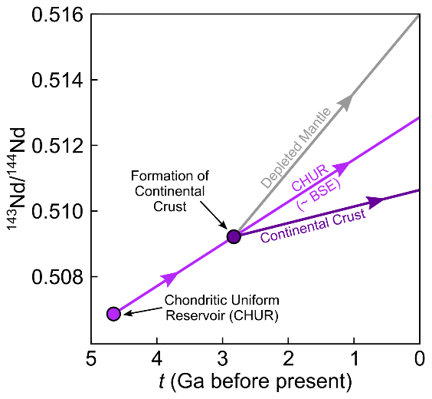
(no expectation to show actual values on the y axis)

Question 2

Detail how oxygen isotopes in different archives (e.g. foraminifera, ice cores, pore waters) can be used to reconstruct past ocean temperature. Include in your discussion a description of the processes that can cause uncertainty in the temperature determination and how some of these may be circumvented.
[25 marks]

Shown in the 1950’s (Epstein 1953) that fractionation of d18O between calcite and seawater related to temperature. Fractionation factor, , experimentally determined for calcite-water system. e.g. 10³ln = 2.78(10⁶T⁻²) – 2.89 (O’Neil 1969). Similar sort of relationship for aragonite. BUT: assemblages of dead organisms do not represent assemblages of living because a) selective dissolution of thin walled specimens; b) differential removal of easily transported specimens; and c) contamination of assemblages by transport from elsewhere. Some marine sedimentary regions are thought to limit these effects. The oxygen isotope system must be corrected for the change in seawater caused by the ‘ice-volume’ effect. This can be done by sampling benthic forams – e.g. bottom waters that are at 4°C – no reason to think they would be colder in ice ages – therefore only change in these species is due to ice-volume effect – gives calibration. Care must be taken with species selection because some produce carbonate not in equilibrium with water – called vital effect – choose species that are in full equilibrium with water or have constant/calibrated vital effect. Also must take care that the test habitat is constrained – ie planktic forams may have different depth habitats depending where and when they live – distorting surface temperature determination – factors include water density (T and salinity) life cycle, seasonality and salinity of seawater. Excellent archive is pore water because it traps ocean water directly although diffusive effects need to be considered.

Question 3

The redox potential of acidic groundwater (as an Eh value) is measured as +0.10 V. The iron half-reaction Fe³⁺ ⇋ Fe²⁺ + e- , has an E⁰ = +0.16V. pE = 16.9Eh. Using:

$$pE=pE^{o}-\frac{1}{n}\log{\frac{\left[\operatorname{Re}{d}\right]}{\left[Ox\right]}}$$

- calculate the ratio of Fe²⁺ to Fe³⁺ ions dissolved in the stream.
[15 marks]
$$pE=16.9Eh=16.9×0.1=1.69 \\ pE^{0}=16.9×0.16=2.70$$

$$1.69=2.70-1×\log{\frac{\left[{Fe}^{2+}\right]}{\left[Fe{}^{3+}\right]}} \\ 1.69-2.70=-\log{\frac{\left[{Fe}^{2+}\right]}{\left[Fe{}^{3+}\right]}} \\ \frac{\left[{Fe}^{2+}\right]}{\left[{Fe}^{3+}\right]}=\frac{1}{10^{-1.01}}=10.23$$

- Is this what you would expect from consideration of the Eh values given in the question? [5 marks]

Most Fe2+. This is expected because the groundwater is slightly less oxidising than the Fe reaction so you would expect more of Fe2+.

- Before any precipitation of iron oxides and hydroxides, what will happen

to the ratio of Fe²⁺/Fe³⁺ ions as the groundwater is exposed to the atmosphere and why? [5 marks]
It will decrease as Fe2+ oxidises to Fe3+ on contact with the oxidising
atmosphere
END OF EXAMINATION PAPER

